With reference to the table that have been created, write an appropriate SQL statement for the following questions. You are also required to provide the output of the SQL statements.

- Display staff id, staff name and their telephone number. Label the columns as No Kakitangan, Nama Kakitangan and Telefon respectively. Order the query in ascending order by staff id.
SQL statements:
select staffid "No Kakitangan", staffname "Nama Kakitangan", staffphone "Telefon"
from staffs
order by staffid asc

Output:
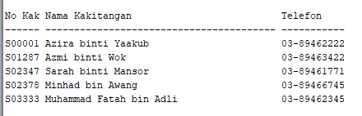

- Display staff id, staff name, and staff address. Display only those who stay in Selangor. Label the columns as Staff-ID, Student-Name and Student-Address respectively. Order the query in ascending order by staff id.
SQL statements:
select staffid "Staff-ID", staffname "Student-Name", staffaddress "Student-Address"
from staffs
order by staffid asc

Output:
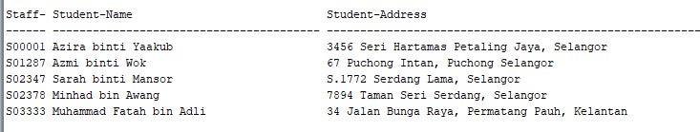

- Analyze the following screenshot. Write a query that will produce output with the same format as the screenshot.
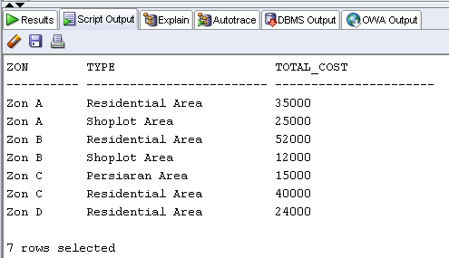

SQL statements:
select 'Zon ' || area_zonid as "ZON", area_type as "TYPE", sum(area_cost) as "TOTAL_COST"
from area
group by area_zonid, area_type
order by area_zonid;

- For each contractor, display company name, contract owner, contract class level and area total cost. Label the columns as CompanyName, ContracOwner, ContractClass and TotalAreaCost respectively. Order the query in ascending order by area total cost. Hint: contract class level is determined by conprice in table Contractor.
SQL statements:
select c.companyname "CompanyName", c.conowner "ContractOwner", cc.classlevel "ContractClass", sum(a.area_cost) "TotalAreaCost"
from contractor c
join area a on c.conid=a.area_conid
join contract_class cc on c.conprice
between cc.min_cost and cc.max_cost
group by c.companyname, c.conowner, cc.classlevel
order by sum(a.area_cost)

Output:
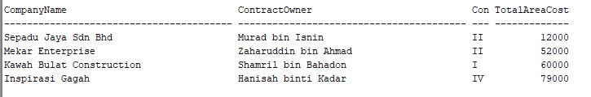

- Display zone id, zone description and average area cost for those area having more than the average area cost of zon D. Label the columns as ZonID, Description, and AverageCost respectively. You are required to use sub-query in answering this question.
SQL statements:
select z.zonid "ZonID", z.description "Description", avg(a.area_cost) "AverageCost"
from zon z
join area a on z.zonid=a.area_zonid
group by z.zonid, z.description
having avg(a.area_cost)>(select avg(area_cost) from area where area_zonid='D')

Output:
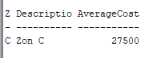

- Display manager id, manager name for every staffs including those without manager id (i.e. null value). If exists null value, replace it with appropriate values. Order the query in ascending order by the manager id column. Give appropriate labels.
SQL statements:
select nvl(s.staffmgrid, 'No Manager') "Manager ID", nvl (m.staffname, 'No Manager') "Manager Name", s.staffname "Staff Name"
from staffs s
left outer join staffs m on (s.staffmgrid=m.staffid)
order by s.staffmgrid

Output:
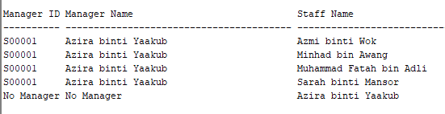

- Display zone id, company name and total area for each zone. Label the columns as ZonID, Company-Name, and Total-Area respectively. Order the query in ascending order by zone id.
SQL statements:
select a.area_zonid "ZonID", c.companyname "Company-Name", count(a.area_conid) "Total-Area"
from contractor c join area a on c.conid=a.area_conid
group by a.area_zonid, c.companyname
order by a.area_zonid

Output:
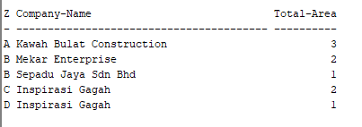

- Display number of contractors, number of area and total area cost of all zones. Your output must be in the same format as shown in the following screenshot.
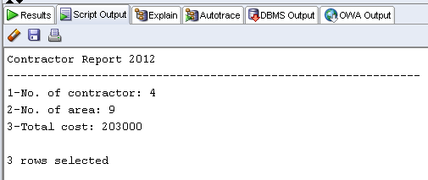

SQL statements:
select '1-No. of contractor: ' ||count(distinct(c.conid))||chr(10)||'2-No. of area: '||count(a.areaid)||chr(10)||'3-Total Cost: '||sum(a.area_cost) "Contractor Report 2012"
from contractor c right outer join area a on conid=area_conid

For question 9 – 12 you are not required to provide the output of the SQL statement.

- Modify STAFFS table to add STATUS column. The data type for the new column is varchar2 (6).

SQL statements:
alter table staffs
add status varchar2(10)

- Prepare ONE (1) query language that will update the value of STATUS column to ‘Supervisor’ which will affect only three staffs at zone B, C and D.

SQL statements:
update staffs
set status='Supervisor'
where staffzonid in ('B', 'C', 'D')

- Remove CONTRACTOR table from the database.
drop table contractor cascade constraint

- Give Salmi privileges to select, insert, update and delete on STAFFS table.

SQL statements:
grant select, insert, update, delete on staffs to salmi

